

**‘Let us be united by knowledge’**

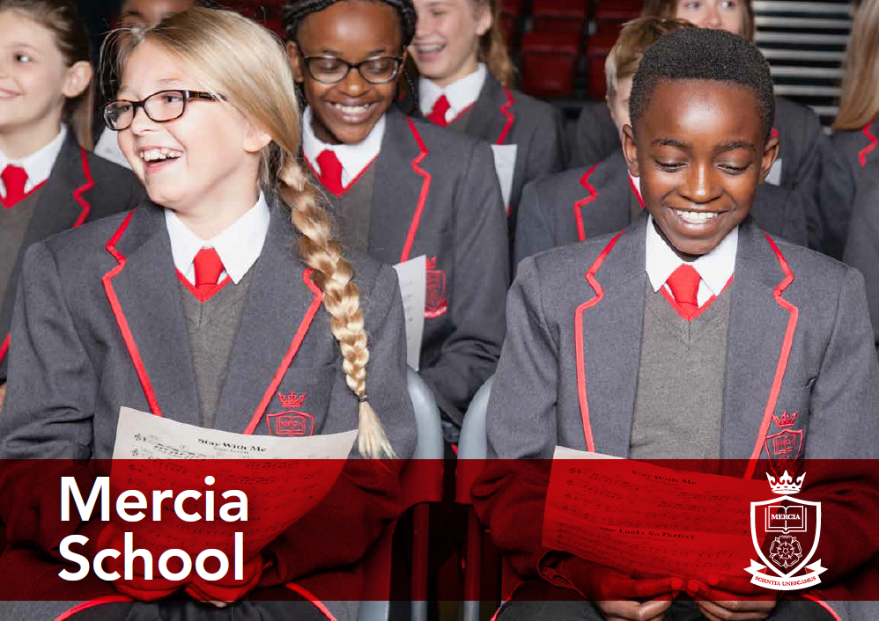

Science Technician: Grade 3

Part-time, 2 days a week

Information Pack

School Information

Job Description

Person Specification



Contents:

* Information about the Mercia Learning Trust
* Letter from the Headteacher
* Job Description
* Person Specification



**‘Let us be united by knowledge’**

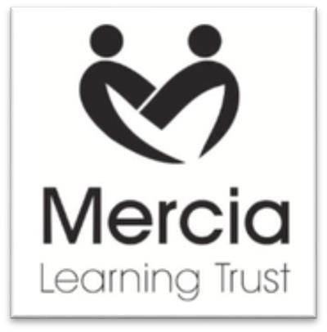

**THE MERCIA LEARNING TRUST**

The Mercia Learning Trust, established in January 2014, currently comprises: Mercia School, King Ecgbert School, Newfield School, Totley Primary School, Valley Park Community Primary School and The Nether Edge Primary School.

The mission of the Trust is to provide an outstanding education for pupils from 0-19. We are passionate that all our pupils should see their time at school as happy and fulfilling, with their potential developed to the utmost. Our approach is founded on partnership working — binding together our schools, parents and their communities.

At all Mercia Learning Trust schools our pupils will benefit from:

* A fully inclusive approach, maximising the attainment and achievement of every pupil;
* A broad and balanced curriculum, with high quality teaching that responds to individual needs;
* Promotion of resilience and self-reliance in our learners, thus enabling them to meet the challenges and opportunities of the changing world;
* Support to develop and maintain positive well-being in all aspects of life;
* High standards of orderly behaviour rooted in strong moral values;
* Continual investment in the professional development of all our staff, as the foundation of our offer to pupils.

For more information, please visit our website: [www.mercialearningtrust.co.uk](http://www.mercialearningtrust.co.uk)



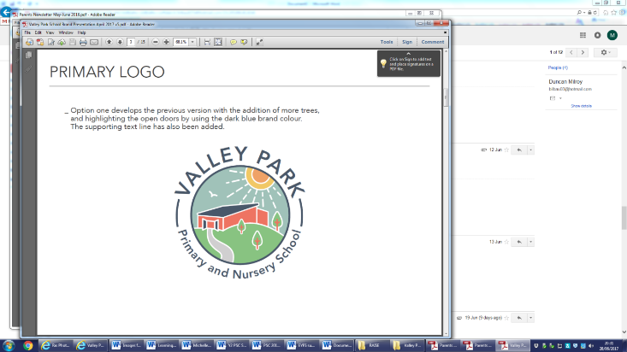  



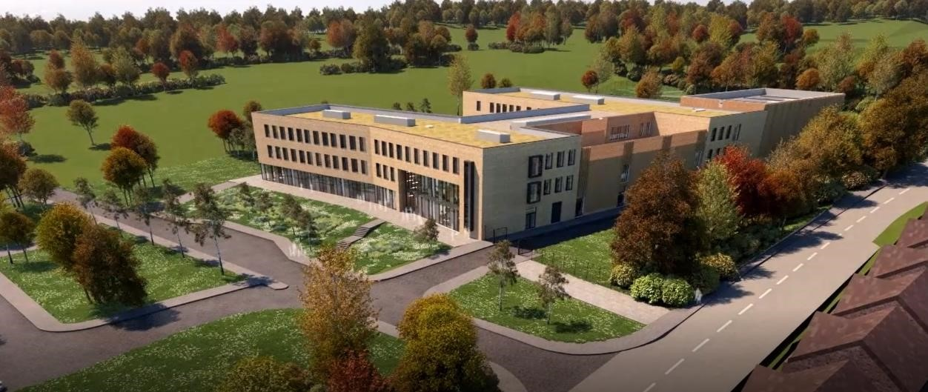

Dear Applicant

Mercia School is a brand new 11-18 school that will serve the south-west of Sheffield. The school will open in September 2018 with 120 Year 7 pupils and grow incrementally for 7 years. Mercia School is part of the Mercia Learning Trust, a local and ambitious Trust that is dedicated to improving the life chances and careers of its pupils and professionals.

Mercia School will provide all pupils, no matter their background or starting point, a rich and demanding education that will inspire. Mercia School will be different. The curriculum will be purely academic with a focus on acquisition of knowledge at its heart. Pupils will receive high levels of challenge in their studies and be supported to achieve accelerated progress. We will set the highest aspirations for our pupils so they can achieve their individual potential and personal ambition.

Mercia School will be a traditional school, following the practices of the very best schools in the land. In essence, Mercia School will share the traits of elite schools, however, we will be a non-selective comprehensive school. We will drive social mobility and achievement for all.

Mercia School will expect that teachers teach from the front with excellent subject knowledge. Our classrooms will be arranged in rows with pupils learning things by heart. We will cherish our teachers’ passion for developing their craft and specialism by ensuring they have time and energy to be reflective. CPD and a transparent team approach to improving practice will ensure we achieve our ambitions together.

Underpinning the ambitious curriculum and teaching will be a consistent discipline approach. Behaviour at the school will be of the highest standard. We will employ a firm approach to behaviour, systematically supported by the senior staff. This will enable our teachers to prioritise the planning and teaching of subject knowledge. We will also have a rich culture of celebration, supported through a traditional house system model, that will highlight and celebrate exceptional performance and excellence in all its forms.

As Headteacher, I am excited about the prospect of leading my team into the new school. It is imperative that I have a team of staff that are truly excellent and fully committed to building a world-class school for its community.

I am seeking a highly talented individual, with a thirst to learn, to serve as the school’s Science Technician on a Grade 3. Initially, the position is for 2 days per week but has obvious potential to grow as we develop as a school. The 2 days are flexible across the whole week and will be discussed at interview.

You will have a chance to be part of a brand-new school, with passionate staff that want the best for its pupils. This is a once in a career opportunity, with obvious career potential. You will work within a dedicated team of individuals who value hard work and positive relationships – Mercia School will be a very enjoyable place to work.

You will be required to work harder than you have ever done before with unrivalled passion, as we shape our world- class school. You will be professional, ambitious and have a hunger to be the best you can be. You will be excited at the prospect of being part of a newly formed team, as we deliver truly excellent standards for our pupils. As the school’s Science Technician, you must absolutely believe that every pupil is entitled to a first-class education, no matter their background or ability, achieved through the acquisition of core knowledge.

If this letter has filled you with excitement and you believe you are the person I am looking for to join our movement, I would welcome your application.

Mercia Learning Trust is committed to providing high quality support, training and opportunities for your professional development.  The opportunity for learning and development for both teaching and support staff are such that there has never been a more exciting time to join our fantastic schools.

Mercia School is committed to safeguarding and promoting the welfare of pupils and expects all staff and volunteers to share this commitment. Successful candidates will need to undertake an Enhanced Disclosure via the DBS and/or provide police checks from other countries, where appropriate. Mercia School is an equal opportunities employer.



**Dean F Webster**

**Headteacher Mercia School**



**‘Let us be united by knowledge’**

**Mercia School**



**Post: Science Technician**

**Contract type: 2 days per week**

**Contract term: Fixed Term**

**Salary: Grade 3**

**Commencement Date: 1 September 2018**

**We are seeking to appoint an outstanding individual.**

**The right candidate should possess:**

* A keen eye for ensuring the safety of our pupils;
* An alignment to a can-do culture;
* The capability to maintain effective relationships;
* A passion for working with young people;
* The talent to adapt to changing situations and learn new skills;
* Strong principles that are aligned with the school;
* Superb communication skills and the ability to relate positively to children and adults;

**Previous technician experience is not essential. We seek talented people.**

**We welcome applications from talented, ambitious individuals who can dedicate themselves to the implementation of the school’s vision and values. Please email completed application forms or any enquiries about this post to estaley@newfield.sheffield.sch.uk**

If you do not believe in the ethos and mission of Mercia School, please do not apply.

[www.merciaschool.com](http://www.merciaschool.com)

**Closing date for applications: Fri July 20, 2018**

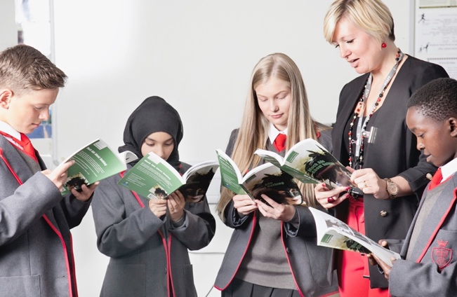

**‘Let us be united by knowledge’**

**Job Description**



|  |  |
| --- | --- |
| **Post Title:** | **Science Technician** |
| **Grade:** | **3** |
| **Hours/Weeks:** | **15 hours / 39 weeks per year** |
| **Responsible to:** | **Head of Science** |
| **Responsible for:** | **Not applicable** |

**The post holder must at all times carry out his/her responsibilities within the spirit of School policies and within the framework of the Education Act 2002, and School Standards and Framework Act 1998 with particular regard to statutory responsibilities of the Governing Bodies of Schools.**

**PURPOSE OF THE POST**

* To provide efficient and effective Technician support to the Science Department

**ANTICIPATED OUTCOMES OF THE POST**

* A responsive, effective and professional technician support service which has been fully embedded across the department and:
* Is consistent in its practice
* Demonstrates continuous improvement through activity
* Demonstrates an ethos where problems are minimised and managed
* Planned and coordinated work schedules
* Acts as role models in demonstrating professional technical support

**KEY RESPONSIBILITIES**

1. To prepare and set up equipment and materials ready for use in accordance with manufacturer’s instructions and the requirements of teaching staff ready for use in teaching areas.
2. To put away equipment and materials, dispose of used materials and chemicals in a safe manner and to maintain hygiene (including cleaning of sinks) and safety standards in the laboratory and preparation areas.
3. To undertake minor repairs, maintenance, modifications to equipment as necessary and in accordance with manufacturers’ instructions. Making arrangements for servicing and any major repairs as necessary.
4. To ensure that equipment is kept clean and in good condition.
5. To operate a safe and secure system for the storage and racking of equipment and materials ensuring that they are maintained in good condition and are readily available for issue.
6. To maintain and monitor stock levels, carrying out regular checks as required and ordering equipment/consumable goods or notifying line manager as appropriate.
7. To assist in compiling inventories of equipment and materials as required in particular with regard to compliance with COSHH regulations.
8. To assist with the operation, development and maintenance of administrative procedures relating to technical duties and in accordance with stated requirements.
9. To assist teaching staff with the general running of practical work sessions in a support capacity.
10. To liaise with teaching staff to develop new practical ideas and advise on schemes of work.
11. To develop new systems in the laboratories and prep rooms to improve the technical support service.
12. Issue and receive goods/materials and maintain a booking system checking goods both in and out.
13. To contribute to the design, development and production of specialist resources, including photocopying, laminating, etc. as directed by the Head of Science.
14. To manage the Inventory.
15. To ensure an up to date chemical database exists.
16. To operate laboratory documentation systems including organisation of work sheets, filing, hazard data and legal records.
17. To keep up to date with curriculum developments within the areas of the postholder’s responsibility.
18. To undertake safety checks as required and ensure compliance with the requirements of Health and Safety, COSHH, and other relevant legislation and school documentation.
19. To undertake recognised training as necessary and attend department meetings.
20. To observe safe working practices in carrying out the required duties and to adhere to instructions specified by technical consultants and manufacturers.
21. Adapt to the changing demands of the school curriculum.

**WORKING ENVIRONMENT AND CONDITIONS OF THE POST**

* Due to the routine of the schools, the workload may not be evenly spread throughout the year.
* In order to deliver the service effectively, a degree of flexibility is needed and the post holder may be required to undertake some duties not specifically referred to above. Such duties, however, will fall within the scope of the post, at the appropriate grade.

**GENERAL DUTIES**

* To contribute to whole school events as and when required.
* To ensure accurate records are securely maintained and held in accordance with General Data Protection Regulations (GDPR)/Data Protection Act 2018.
* Be aware of and support diversity, ensuring equal opportunities for all.
* Develop professional, constructive relationships with other agencies, schools and professionals.
* Participate in meetings, training and performance development as necessary.
* Recognise own strengths and areas of expertise using these to advise and support others.
* Be willing to undertake training and professional development as required of the post.
* Any other duties and responsibilities appropriate to the grade and role.

**PROMOTION OF TRUST VALUES**

* To contribute to the overall development of Mercia Learning Trust to ensure the Trust operates on the basis of shared and collective responsibility.
* To contribute to the overall ethos, work and aims of Mercia Learning Trust.
* To support and contribute to the Trust’s commitment to safeguarding all students. All schools in the Mercia Learning Trust are committed to safeguarding and promoting the welfare of children and young people. Therefore, all employees are expected to share this commitment.
* To be aware of the school’s duty of care in relation to staff, students and visitors and to comply with all health and safety policies at all times.
* To be aware of and comply with the codes of conduct, regulations and policies of the School and its commitment to equal opportunities.
* All the above duties and responsibilities to be carried out in accordance with policies adopted by the School Governing Body and current legislation with an emphasis on Customer Care, Equal Opportunities, Data Protection and Health and Safety

This job description is current at the date indicated below but, in consultation with the post holder, it may be changed by the Headteacher/CEO to reflect or anticipate changes in the post commensurate with the grade or job title.

**Issue Date: July 2018**

**Person Specification**



|  |  |  |
| --- | --- | --- |
| SPECIFICATION | ESSENTIAL | DESIRABLE |
| Qualifications/ Training | 5 GCSE’s grade C or equivalent with a least one in a science subject  Good numeracy literacy and ICT skills | A-Levels and degree |
| Experience | Proven experience in a similar role.  Experience in working with chemicals and scientific equipment  Experience of procuring materials including stock control | Scientific background, previous experience as a lab technician  Previous experience of working with children in an educational or similar learning environment |
| Knowledge/Skills (Ability to) | *The ability to converse at ease with members of the public and students and provide advice in accurate spoken English is essential to the role  Able to work well with students and staff  Works constructively as part of a team, understanding classroom roles and responsibilities and your own position within these  Good understanding of health and safety procedures and can maintain a safe working environment  Ability to create new experiments, construct appropriate equipment and keep up to date with current thinking in school science  Uses technology to support the role  Good communication skills  Can complete and maintain administrative records | Is aware of techniques to manage the behaviour of students to ensure their safety in class  Appropriate knowledge of first aid |
| Personal Qualities | Can maintain personal presentation that sets high standards for the students  High level of personal integrity  Highly organised  Methodical  Genuine enthusiasm and the ability to work well within a wider staff team. |  |

**If this does not excite you, please do not apply.**

**We welcome applications from talented, ambitious individuals who can dedicate themselves to the implementation of the school’s vision and values. Please email completed application forms or any enquiries about this post to: estaley@newfield.sheffield.sch.uk**